**Access Control Matrix for Tech Tribe**

**Purpose**

This document establishes an Access Control Matrix (ACM) for Tech Tribe, an IT consulting and software development company operating across various IT sectors. The ACM ensures secure, efficient, and compliant management of permissions for different roles, aligning with organizational goals and security policies. By clearly defining access levels while preventing conflicting roles, the ACM protects sensitive systems and data while promoting operational integrity.

**Scope**

This matrix applies to Tech Tribe’s diverse operations, including IT consulting, software development, financial management, and client interaction. It defines access permissions for internal systems and resources such as development tools, financial databases, project management platforms, and client information.

The scope includes:

* Assigning role-based permissions aligned with job responsibilities.
* Preventing conflicts of interest by identifying incompatible roles.
* Applying the least privilege principle to ensure security.
* Adhering to industry best practices and compliance standards.

**Overview**

An **Access Control Matrix (ACM)** is a structured framework that defines and manages access to organizational resources based on roles and responsibilities. It is a cornerstone of security and operational integrity, ensuring that employees have access to the tools and information they need while safeguarding sensitive systems.

**Why It Is Used**

The ACM supports:

* **Security**: By limiting access to critical systems and sensitive data, the ACM reduces the likelihood of unauthorized access or data breaches.
* **Separation of Duties**: Prevents conflicts of interest or the possibility of malicious or accidental misuse by ensuring key responsibilities are divided among different roles.
* **Compliance**: Meets regulatory and industry standards, such as GDPR or ISO 27001, ensuring data protection and organizational accountability.

**Tech Tribe’s ACM**

Tech Tribe’s ACM is tailored to meet the needs of its IT consulting and software development operations. The matrix enables employees to focus on their responsibilities while protecting organizational assets. By thoughtfully allocating permissions and identifying restricted role combinations, the ACM supports secure, efficient, and compliant operations across all departments.

Picture1: Shows the ACM for Tech Tribe

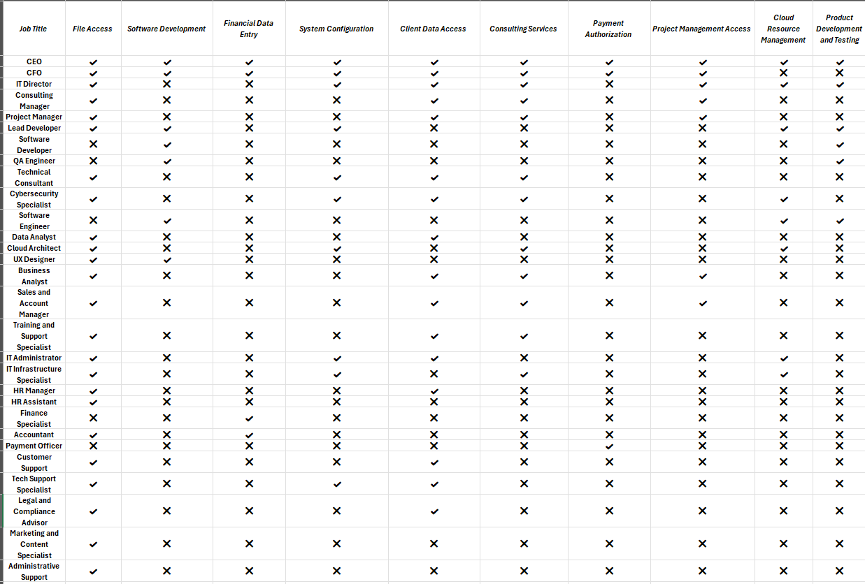

***Tech Tribe Access Control Matrix Rationale***

This Access Control Matrix is designed to support Tech Tribe’s diverse IT consulting and software development operations. Each permission type (column) is thoughtfully allocated to align with job-specific responsibilities. This ensures employees have access to the necessary tools and information to fulfill their roles while maintaining robust security and adhering to the principles of least privilege and separation of duties.

***Access Columns Explained***

1. **File Access**
   * **Roles with Access**: Senior roles (e.g., CEO, CFO, IT Director), Project Managers, Business Analysts.
   * **Roles without Access**: Technical roles not requiring shared document access, such as QA Engineers.
   * **Rationale**: Senior and client-facing roles require access to shared documents for collaboration on projects, strategic planning, and client interaction. Restricting access for technical roles helps them focus on specialized tasks, such as development and testing, without unnecessary distractions.
2. **Software Development**
   * **Roles with Access**: Software Developers, Lead Developers, UX Designers.
   * **Roles without Access**: Non-technical roles (e.g., CFO, Project Manager).
   * **Rationale**: Allowing only development-focused roles to access software systems ensures the integrity of the codebase. Non-developers are restricted to avoid accidental modifications, which could disrupt system functionality or security.
3. **Financial Data Entry**
   * **Roles with Access**: CFO, Finance Specialists, Accountants.
   * **Roles without Access**: Most technical and support roles.
   * **Rationale**: Finance-related permissions are restricted to minimize errors, reduce the risk of fraud, and maintain the confidentiality of financial information. Only individuals responsible for managing finances should have access to these resources.
4. **System Configuration**
   * **Roles with Access**: IT Director, IT Administrator, Cybersecurity Specialist.
   * **Roles without Access**: Non-technical roles (e.g., CFO, Sales).
   * **Rationale**: System configuration access is restricted to technical roles to prevent unintended changes or disruptions. This ensures system stability and reduces vulnerabilities caused by unauthorized alterations.
5. **Client Data Access**
   * **Roles with Access**: Project Managers, Sales Managers, Business Analysts.
   * **Roles without Access**: Technical roles (e.g., QA Engineers).
   * **Rationale**: Protecting client data is a priority for maintaining trust and compliance with privacy regulations. Access is limited to roles that directly interact with clients or manage client relationships to minimize the risk of unauthorized disclosure.
6. **Consulting Services**
   * **Roles with Access**: Consulting Manager, Business Analysts, Technical Consultants.
   * **Roles without Access**: Development and infrastructure-focused roles.
   * **Rationale**: Limiting access to consulting services ensures that client-facing resources are not overwhelmed with tasks outside their purview. It also allows consultants to focus on delivering quality services and achieving client satisfaction.
7. **Payment Authorization**
   * **Roles with Access**: CEO, CFO, Payment Officer.
   * **Roles without Access**: All other roles.
   * **Rationale**: Restricting payment authorization to senior financial personnel reduces the risk of fraud and ensures accountability in financial transactions.
8. **Cloud Resource Management**
   * **Roles with Access**: Cloud Architect, IT Director, IT Infrastructure Specialist.
   * **Roles without Access**: General and client management roles.
   * **Rationale**: Managing cloud resources requires specialized knowledge. Limiting access reduces the likelihood of misconfigurations, which could compromise security or availability.
9. **Product Development and Testing**
   * **Roles with Access**: Software Developers, QA Engineers.
   * **Roles without Access**: Non-technical roles (e.g., CEO, CFO).
   * **Rationale**: By restricting development and testing access to relevant roles, Tech Tribe maintains a controlled environment for product quality and security. This ensures that only authorized personnel can make or test changes.
10. **Project Management Access**
    * **Roles with Access**: Project Managers, Business Analysts, CEO.
    * **Roles without Access**: Technical roles (e.g., IT Infrastructure Specialists).
    * **Rationale**: Assigning project management access only to roles responsible for oversight prevents unauthorized changes and helps maintain clear accountability for project deliverables.